Network Architecture -1

Assignment -1

Name: Vineela Chowdary

Student ID: 16208640

**(1)**

Given distance between two hosts=20,000 kms

Transmission rate of link=1 Mbps=1*10 power 6 bps

Propagation speed over the link=2*10 power 8 meter/sec

Number of bits send from Host A to Host B(Length )=1,000,000 bits

a) The time taken for the file to be sent if it is sent continuously = propagation delay + transmission delay

Propagation delay = distance/speed(d/s)

=20,000kms/2*10 power 8 m/s

=1/10 sec =0.1 sec

Transmission delay = Length/Bandwidth(L/R)

=1,000,000/1*10 power 6 bps

=1 sec

Therefore time taken for the file is = 0.1+1= 1.1 sec

b) Number of packets=500

Length of each packet=2000 bits

Distance between A and B = 20000kms

Speed of propagation= 2*10 power 8 m/s

Propagation time of packet= d/s

=20000*1000/2*10 power 8

=0.1 sec

Transmission time of packet = L/R

= 2000/1*10 power 6

=0.002 sec

Propagation time for acknowledgement = d/s

=20000*1000/2*10 power 8

= 0.1 sec

Transmission time for acknowledgement = 0

Total time for each packet =0.1+0.002+0.1+0

=0.202 sec

For 500 packets time taken = 500*0.202

=101 sec

c) Bandwidth-delay product=R*propagation delay

=1 Mbps*0.1

=100000 bits

d) Host A---->Router1---->Router2---->Host B

The data should be transferred from Host A to Router1,Router 1 to Router 2 and Router 2 to Host B

There are totally 3 transmissions each having transmission time

Therefore it takes 3sec to send the file.

Delay(transmission) = 3*(Length/Bandwidth) = 3*(1000000/1000000) = 3 sec

Delay(Propagation)=Distance/speed=20000kms/2*100000000=0.1seconds

Propagation time taken for acknowledgement = Distance/Speed = 0.1seconds

For 1 packet = 3+0.1+0.1 = 3.2seconds

**(2)** **J.C.R.Licklider**:

I felt J.C.R.Licklider as interesting because he is the person who contributed his ideas for the development of Internet. He thought of making easy access for computer networks using user interfaces. He is called "Computing Johnny Appleseed" for he planted the seeds of computing in the digital age. He is a man with humbleness and he encourages others to take the credit of his ideas as long as they are accomplished.

I am inspired by his idea of thinking to make man feel comfortable by using computer for solving complex programs. I like a quality of him spending his time to learn something which he needed to know. His ideas has profound effect on the development of computer technology and Internet. He had a concept of Intergalactic network and he worked hard to achieve it.

**Douglas Engelbart**:

The interesting thing about this person is he dedicated his life to the pursuit of developing technology to augment human intellect. His most famous invention is the computer Mouse. He is a man who thought to contribute to mankind and for that he worked restlessly.

He wrote his seminal work, Augmenting Human Intellect: A conceptual framework. The successful implementation of hypertext was done by him through his NLS(Online System). NLS paved the way for on-screen video teleconferencing. His lab SRI became a node on the ARPANET.

I have learned from him to continue the work irrespective of age because he used to work even at the age of 75.

**(3)** **Computer Virus**:

It is a malware program that repeats when executed. It infects the data files, hard drive etc. Viruses usually perform harmful activities on infected hosts like stealing hard disk or CPU time, accessing private information, corrupting data, displaying unnecessary messages. They are self repeating computer programs which are installed by themselves without the permission of user. Creeper virus was the first detected computer virus.

**Worm:**

It is a standalone malware computer program that reproduces by using a computer network in order to spread to other computers. It spread by harming the operating systems. Payload is the code in the work that delete files in host system.

**Spyware**:

It is a software that collects information about a person or organisation without their idea of knowing and send that to another person or organisation without the permission of customer. It also gains control over computer without the consumers knowledge. It collects personal information also.

**Malware**:

Malicious software is a software used to interrupt computer operations. It collects sensitive information and get control over computer systems. It mainly aims to steal information or spy on computer users without their knowledge for a long period. It is also known as computer contaminant .

**Trojan Horse**:

It is a malicious computer program which has wrong idea about itself as interesting one to make a person who doesn't know about it to install it. They are spread by some form of social engineering. Because of this the computer may run slower.

**Botnet**:

It is communication between number of internet connected computers and small machines to complete repetitive tasks. It keeps control of Internet Relay Chart channel and is used to sent spam email. It is combination of words robot and network.

**(4)** **Ping** :

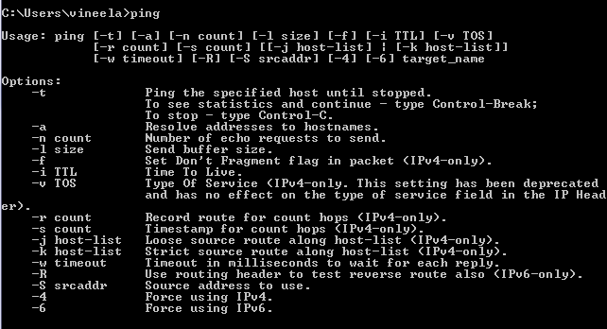

Ping with google.com

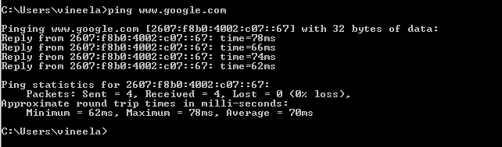

Ping with justfab.com

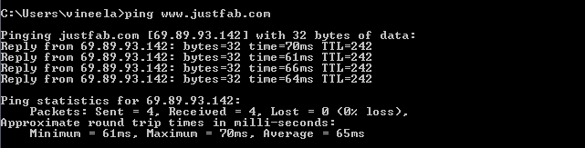

Ping with payless.com 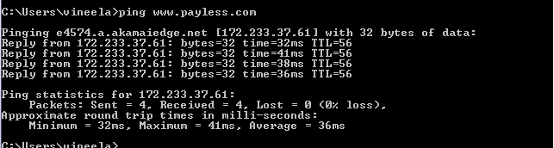

Ping -i: Time to live

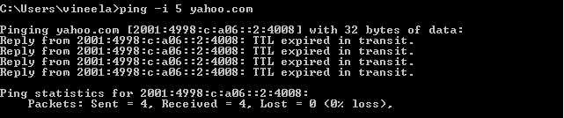

Ping -n: Number of echo requests to send

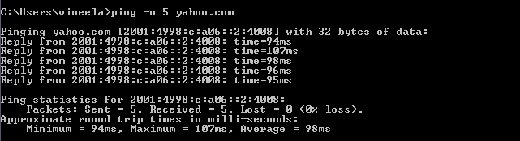

Tracert on Windows

Tracert: 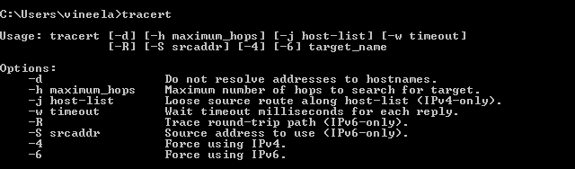

Tracert with forever21.com

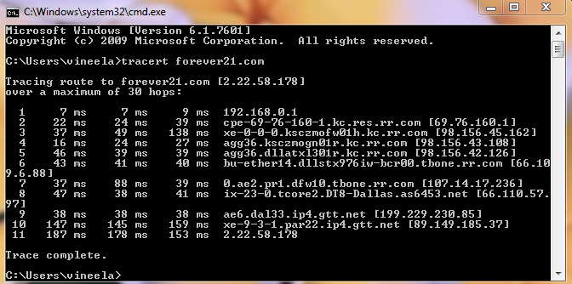

Tracert with facebook.com

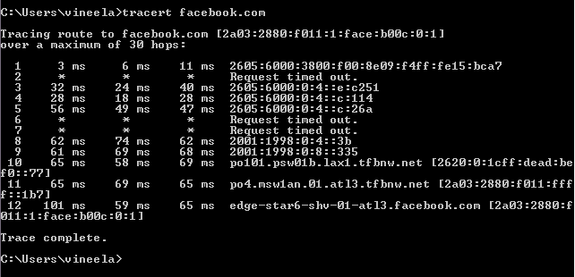

Tracert with burlingtoncoatfactory.com

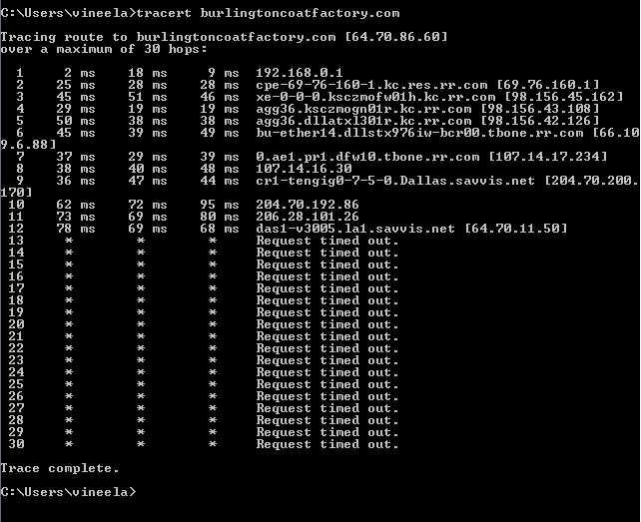

Tracert -d:Do not resolve addresses to host name

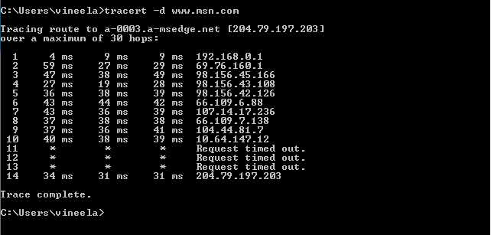

Tracert -h: Maximum number of hops to search for target

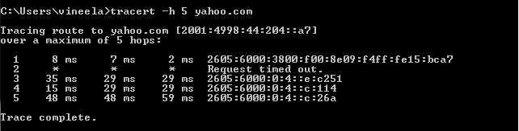

**(5)**

nslookup:

a) ip addresses of [www.yahoo.com](http://www.yahoo.com)

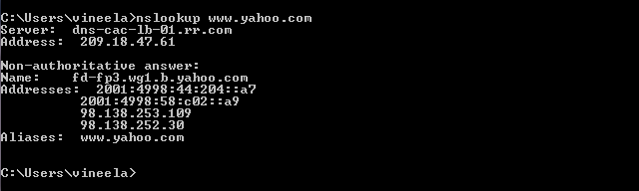

b)Name Servers and ip addresses of yahoo.com

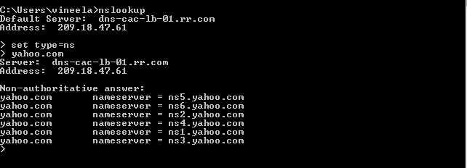

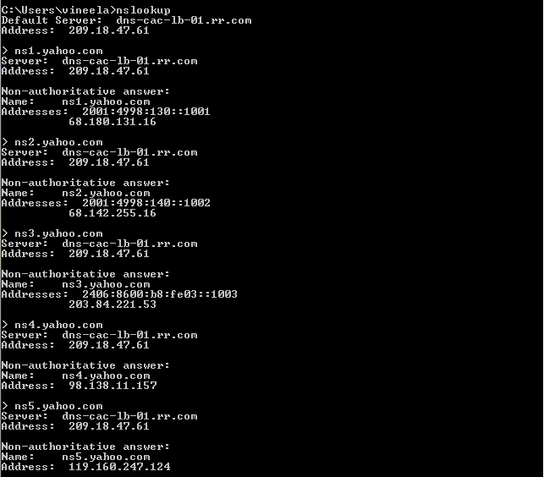

c)Email Servers and ip addresses of yahoo.com

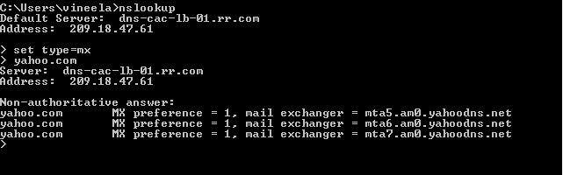

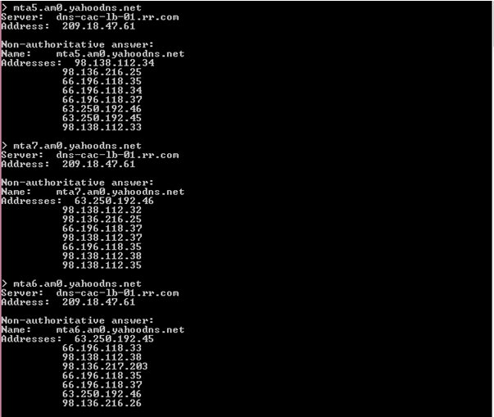

d)Other options of nslookup

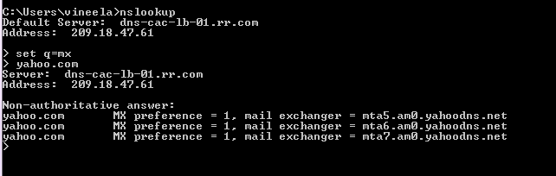

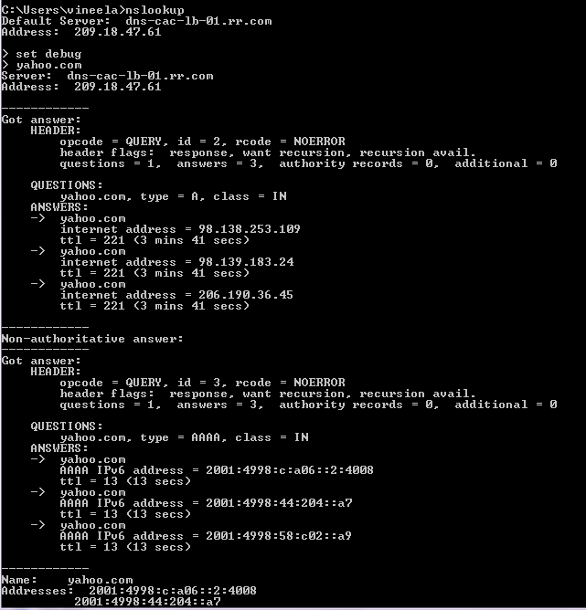

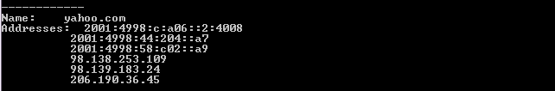

**(6)**

There are currently 7 RFCs.

In IETF working groups are of 2 types. They are

1)Active working group

2) Concluded Working Group

The 5 working groups are:

appsawg: Art Area General Applications Working Group

bfcpbis: Binary Floor Control Protocol Bis

calext: Calendary Extensions

dbound: Domain Boundaries

tzdist: Time Zone Data Distribution Service.

Objectives of TZDIST:

Its main objective is to allow efficient, timely updates of time zone data to the clients.

Time zone data represents the history, current and future local time rules for these regions, together with an associated time zone identifier. The changes in time zone are delivered as operating system updates. By using time zones clients can achieve significant network bandwidth and storage savings.

This working group uses the following drafts:

draft-douglass-timezone-service-11

draft-daboo-caldav-timezone-ref-01

The time zone data is based on Time zone Database but must include any source of time zone data. The tome zone data distribution protocol uses security protocols to protect integrity and confidentiality of data.

The documents/issues published in this working group are

1) CalDAV: Time Zones by Reference

2)Time Zone Data Distribution Service.